**Wind and Waves Conditions off the Coast of Libya during April 2015**

R. Limeburner

April 1, 2016

**Abstract**

This report documents the wind and surface wave conditions observed during April 12 and April 18, 2015 in the Mediterranean Sea approximately 120 km north of Libya when two fishing boats overloaded with migrants from Libya capsized. It is believed more than 1200 migrants died in these two tragic accidents alone despite the presence of rescue boats near each capsized boat. The objective of this report is to determine if the wind and wave conditions at the time of the accidents contributed to the difficulty of the at-sea rescue operations and subsequent deaths of so many of the migrants.

**Introduction**

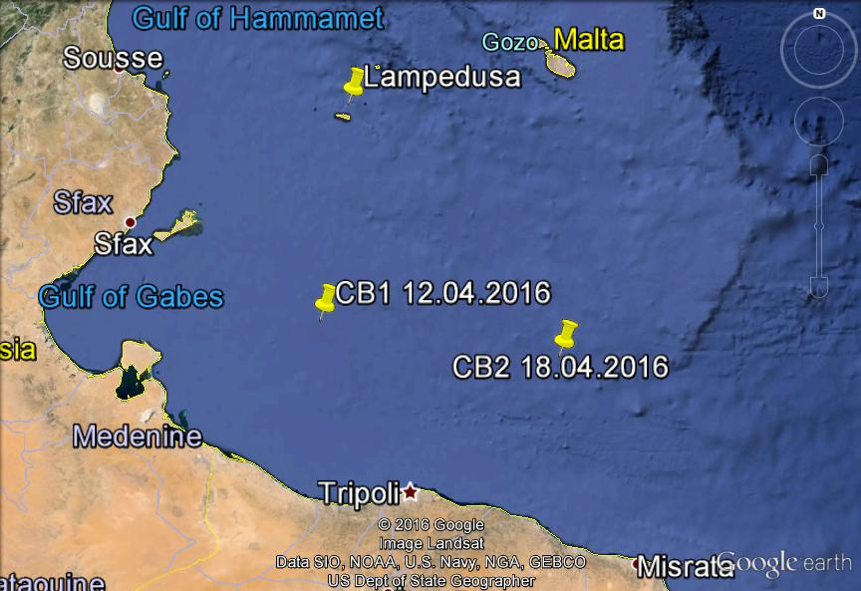

Figure 1. Locations of 2 capsized migrant boats in April 2015.

An estimate of the wind strength and direction during April 2015 is given by the meteorological observations at the Aeroporto di Lampedusa located 157 km north of the 1st capsized boat location on 12.04.2016 (CB1) and 240 km NW of the 2nd capsized boat location (CB2) on 18.04.2016 in Figure 1.

The Lampedusa meteorological observations for the month of April, 2015 are shown in Figure 2.

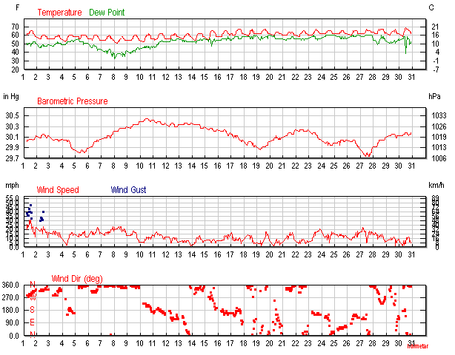

Figure 2. Meteorological observations Aeroporto di Lampedusa April, 2015.

Large-scale atmospheric pressure maps show the winds were similar at Lampedusa Island and the locations/times of the 2 capsized boats in April 2015.Three low pressure storms were observed on April 5, 19 and 27 in Figure 2. Average wind speed was generally less than 15 mph (13 kt) for the month and usually from the NW with possible winds backing from the NW to south during weak storms. Wind gust data for the month was not available. Air temperature showed a 5˚ F diurnal variability between 56˚ and 70˚ F.

**April 12, 2015 1830 (CEST) Migrant Boat Capsizing**

On 12.04.2016 the wind was relatively weak at less than 9mph (7 kt) during the afternoon at Lampedusa Island (Figure 3).

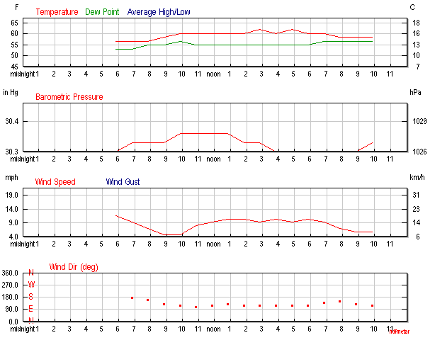

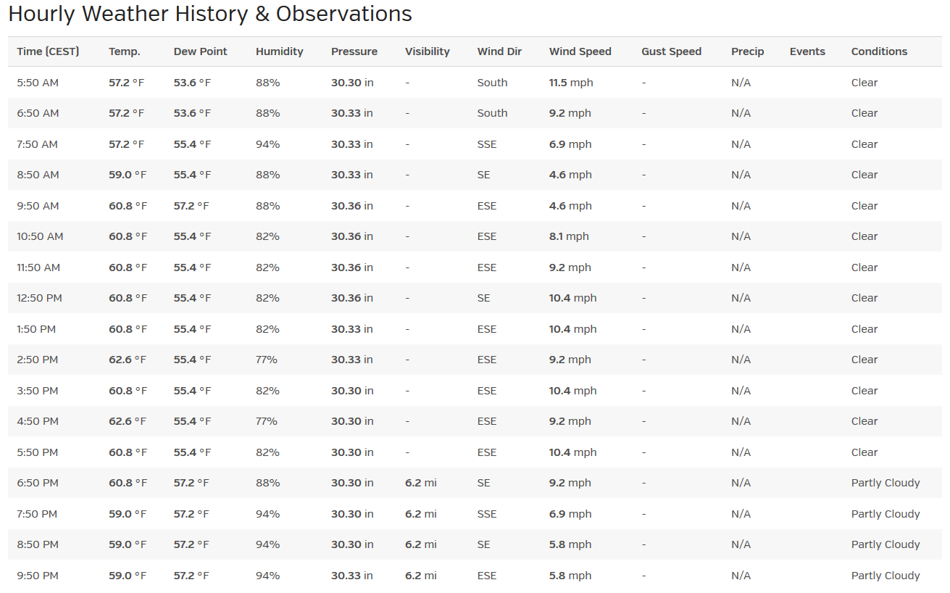

Figure 3. Lampedusa met data 12.4.2016 CEST (UTC +2).

A photograph on 12.04.2016 at 1611 UTC (1811 CEST) of the overloaded migrant boat just minutes prior to the capsizing is shown in Figure 4. This photo was provided to the press by Opielok, the company managing the OOC *Jaguar,* the vessel that observed the capsizing from a distance of only a few 100 m. An oil platform, ENSCO 5004, at the Bouri oil fields was located less than 1 km from the location of the capsizing.

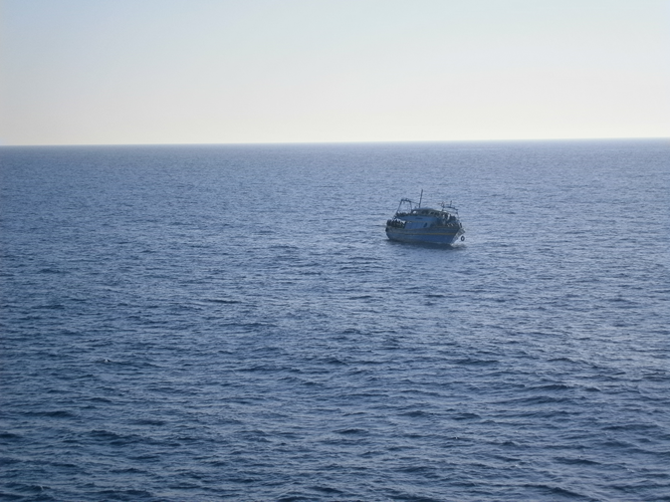

Figure 4. The unstable migrant vessel 12.04.2015 1811 CEST

The Figure 4 photo shows the overloaded migrants’ boat clearly leaning to the port side in the distance. I estimate the wind in this photo to be weak, probably less than 10 kt and the local wind driven waves were < 15 cm high. A low frequency swell is observed in the figure 4 photo is estimated to have a wave length of 2 boat lengths, ~ 100 m, and the wave period would be 7.7 seconds from linear wave theory. The swell height is probably less than 30 cm. Clearly the wind and wave conditions just prior to the capsizing were weak and would not hinder other vessels from rendering assistance.

Figure 5 shows the vessel after the capsizing. The winds and waves were weak and about 80 migrants can be seen standing/sitting on the overturned vessel and another 20 are in the water drowning or swimming toward the vessel where the photo was taken.

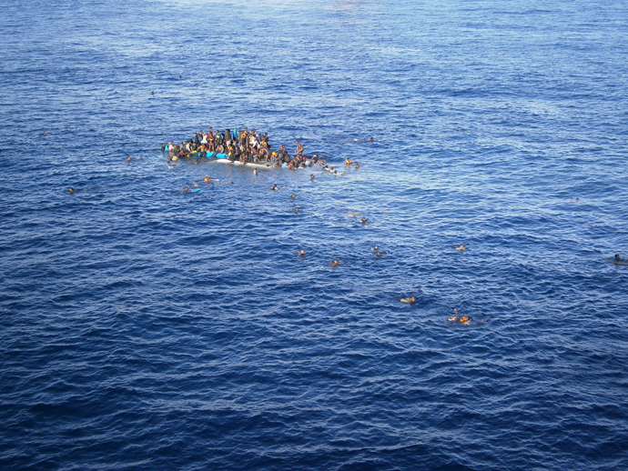

Figure 5. Capsized migrant boat 12.04.2016 1754 CEST.

At 1637 UTC (1837 Italian local time is Central European Summer Time CEST), Maritime Central Rescue Center (MRCC) Rome sent out a distress signal to all vessels in vicinity requesting assistance for the capsized passengers:

HYDROLANT 865/2015 (52,53,56)

EASTERN MEDITERRANEAN SEA. DNC 08, DNC 09. F/V, NUMEROUS PERSONS ON BOARD, CAPSIZED AND ADRIFT IN 34-05.0N 012-24.8E. VESSELS IN VICINITY REQUESTED TO KEEP A SHARP LOOKOUT, ASSIST IF POSSIBLE. REPORTS TO MRCC ROME, INMARSAT-C: 424744220, PHONE: 39 065 908 4527, 39 065 908 4409, FAX: 39 06 592 2737, 39 065 908 4793, E-MAIL: ITMRCC@MIT.GOV.IT.

( 121637Z APR 2015 )

Currents at the sea surface at the time of the capsizing are shown in figure 6. The data and image for the currents were provided by Mercator Ocean, a French nonprofit producer of ocean forecasts and analysis.

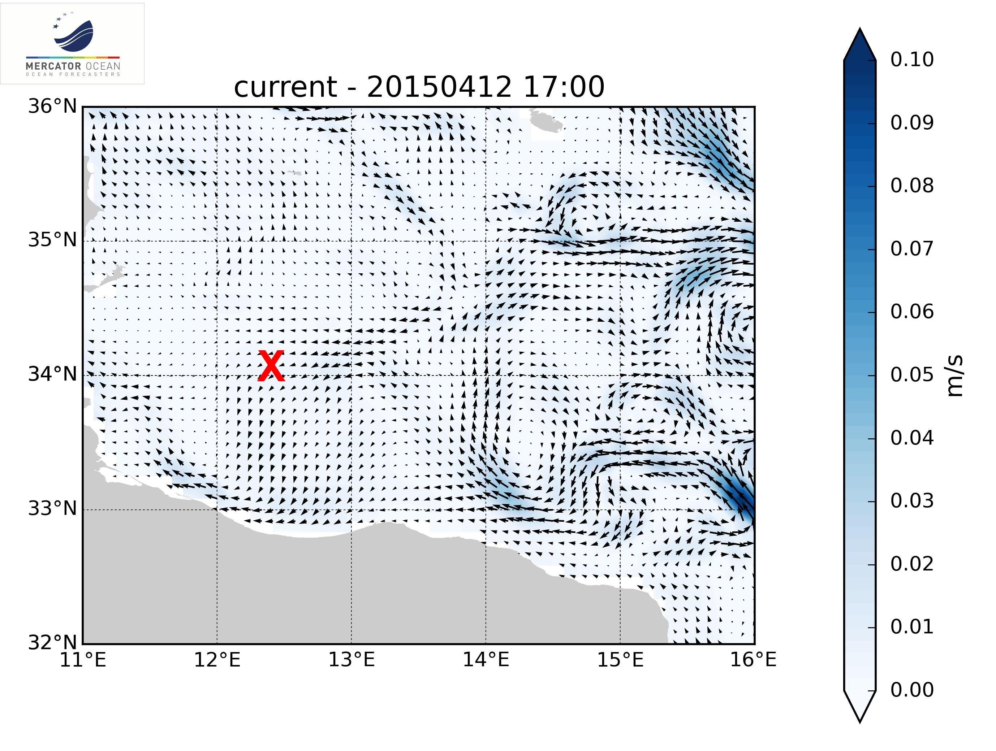

Figure 6. Surface current at the time of the capsizing on 12.04.2016 1754 (CEST).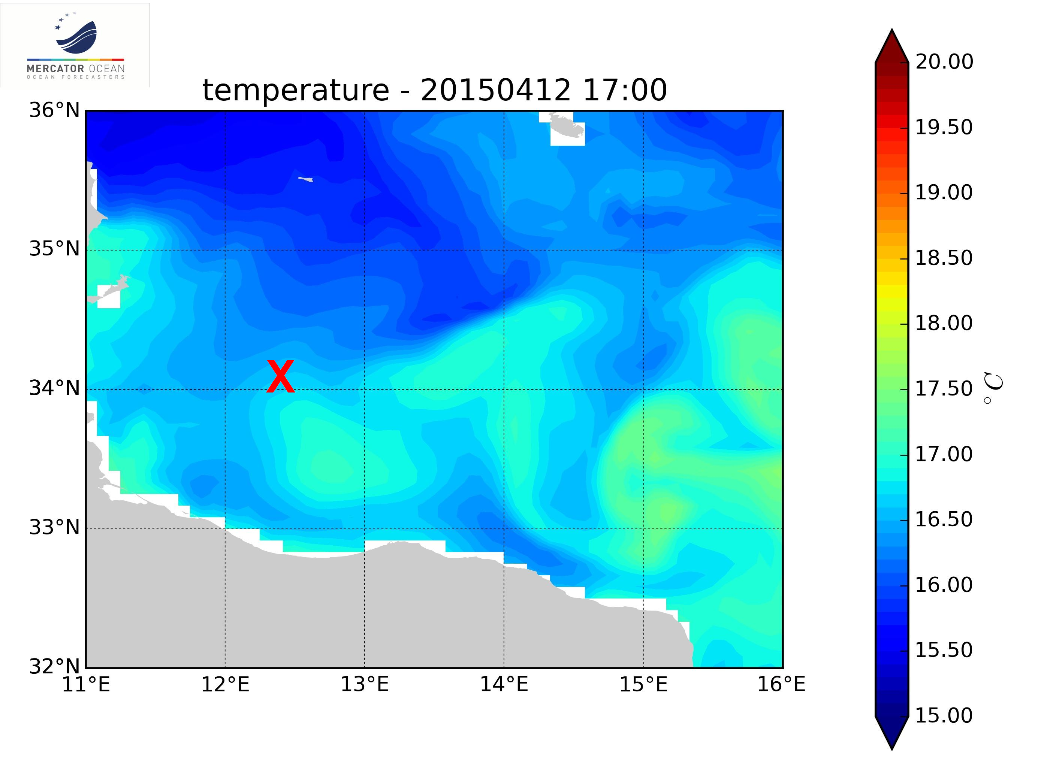

Figure 7. Sea surface temperature at the time of the capsizing.

The Mercator Ocean sea surface temperature map at the time of the capsizing (Figure 7) indicates temperature near 17˚ C at the capsized location and migrants in the water could survive for a few hours.

**April 18, 2016 2328 (CEST) Migrant Boat Capsizing**

On 18.04.2015 at 2328 (CEST) the wind was relatively weak at Lampedusa Island (Figure 8).

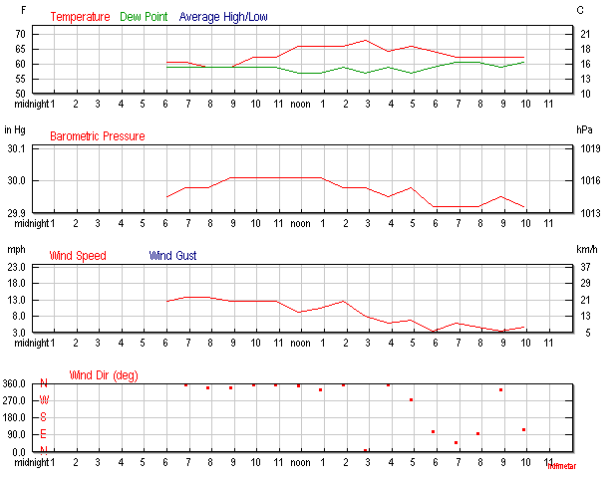

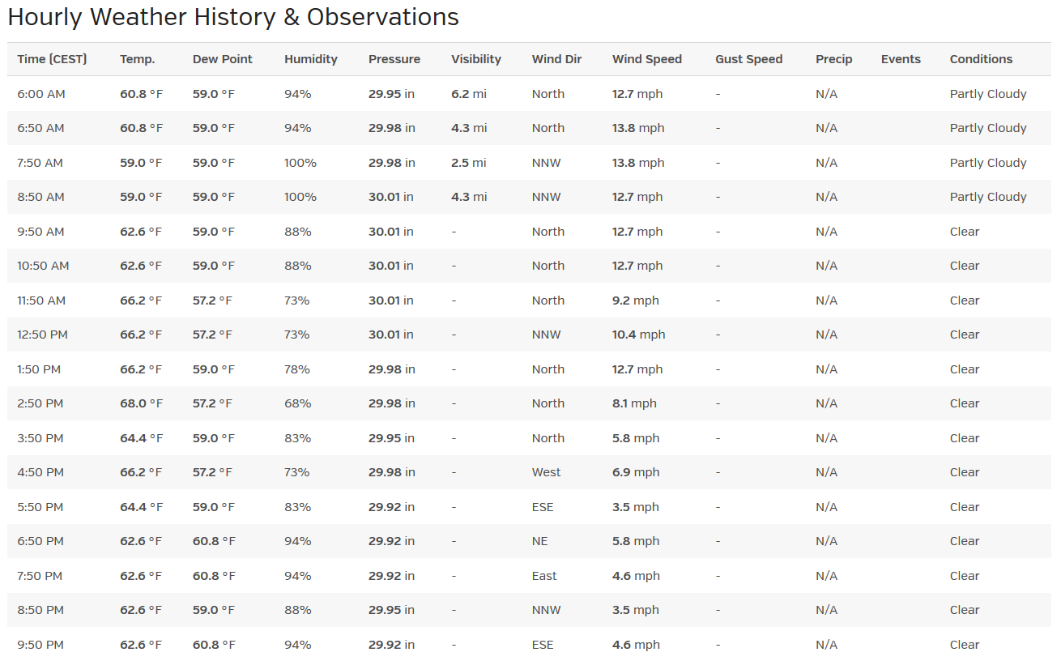

Figure 8. Lampedusa met data on 18.04.2016 (CEST).

The Lampedusa wind data in Figure 8 on 18.04.2016 2200 (CEST) was 5 mph (4 kt) and the wind was probably weak and variable during the entire night. The capsizing took place at 2328 (CEST) and only 28 of an estimated 850 migrants survived. A photo of the rescue operation on Sunday 19.04.2016 is shown in Figure 9.

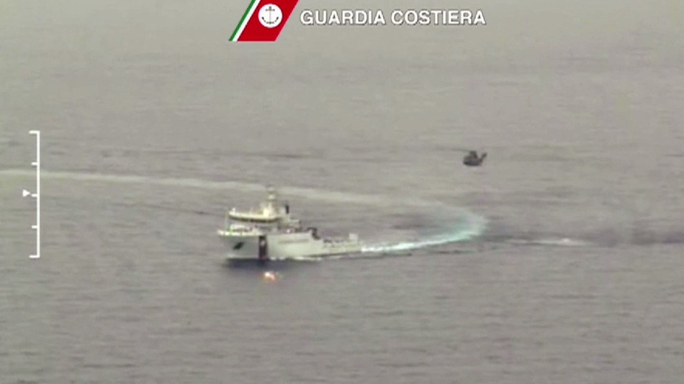

Figure 9. An Italian coast guard vessel and helicopter during ongoing search and rescue operations in the Mediterranean Sea south of Lampedusa Island, Sunday April 19, 2015.

The sea surface in Figure 9 is relatively flat indicating light and variable winds and small surface waves less than 20 cm. Currents at the sea surface at the time of the capsizing are shown in figure 10. The data and image for the currents were provided by Mercator Ocean, a French nonprofit producer of ocean forecasts and analysis.

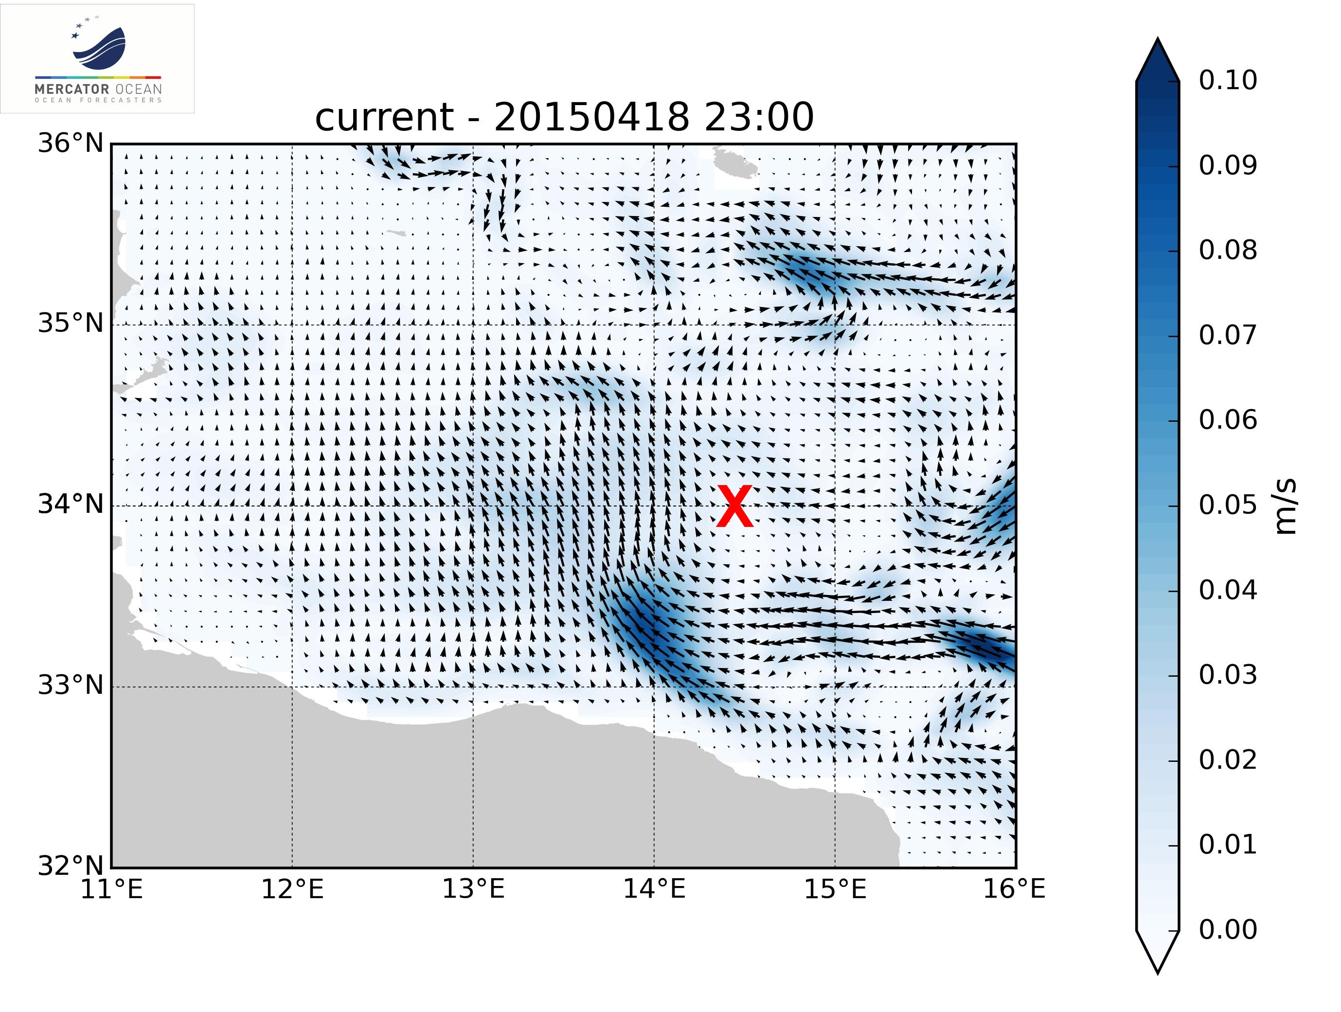

Figure 10. Sea surface temperature at the time of the capsizing.

The current at the location of the capsizing on 18.04.2016 2332 (CEST) was relatively weak and suggests that the rescue operations should have been much less difficult than if the wind, waves and currents had been stronger.

The Mercator Ocean sea surface temperature (Figure 11) at the time of the capsizing indicates temperature near 18 C and the migrants in the water could survive for a few hours.

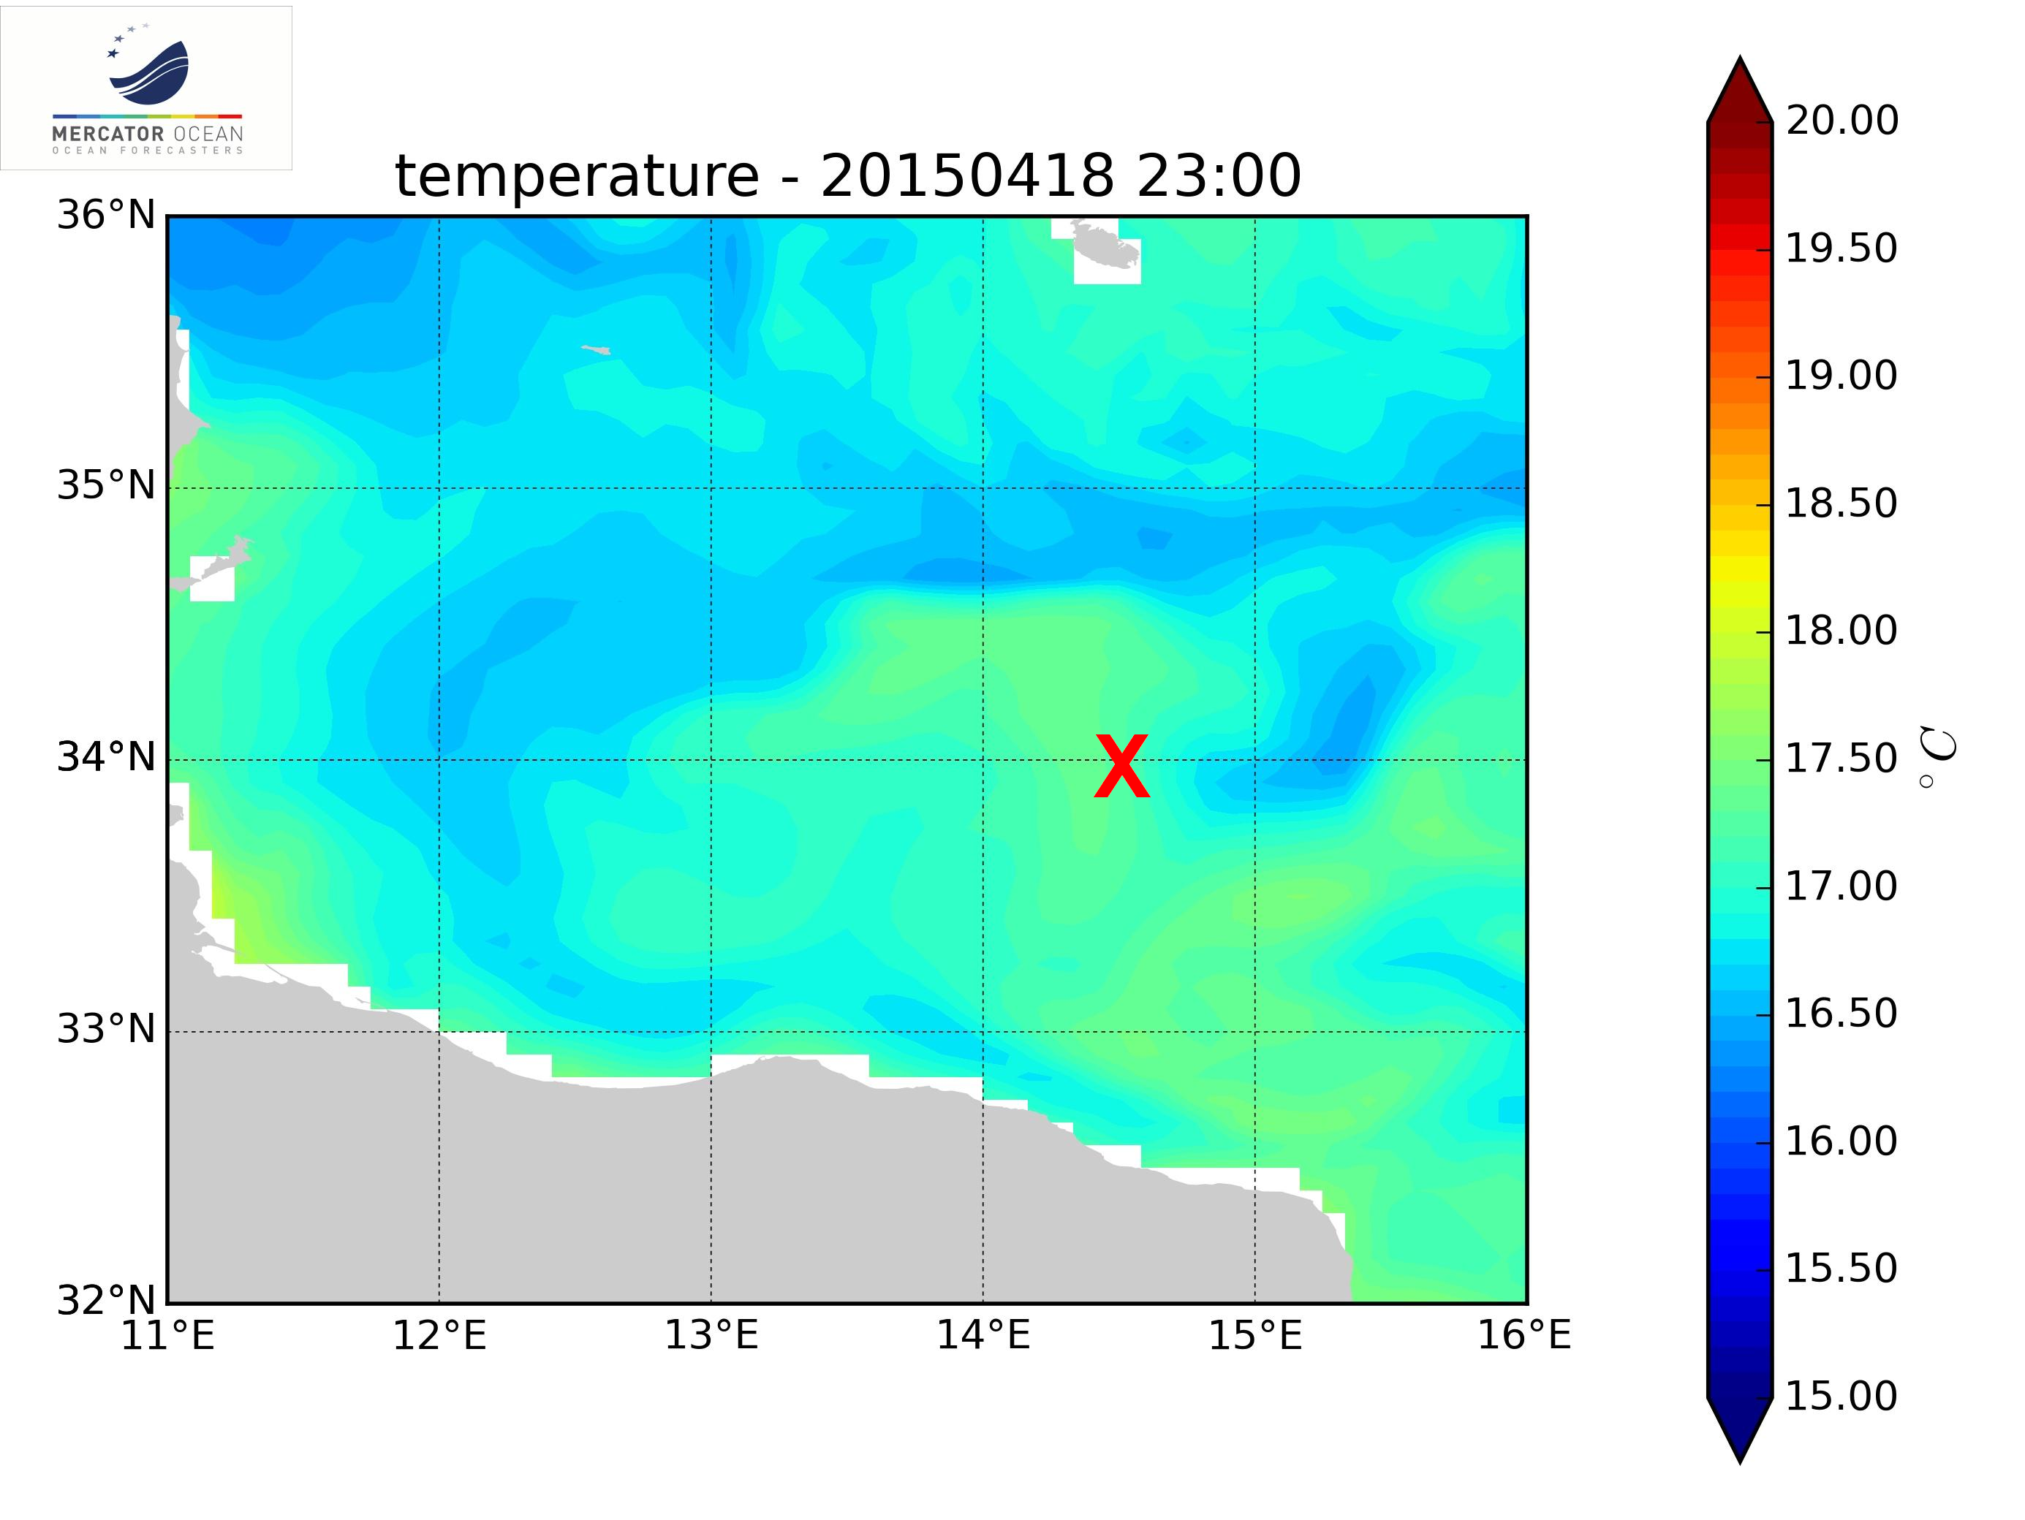

Figure 11. Surface temperature at the time of the capsizing.

**Conclusions**

Light and variable winds and sea surface wave heights less than 15 cm were observed at the 2 locations where migrant boats capsized and sank during April 2015 off the coast of Libya. These conditions would facilitate the at sea rescue operations of the migrants compared to other times when the winds were stronger and the waves were higher. However, over a 1000 migrants died in these 2 accidents due primarily to the lack of safety equipment (especially lifejackets) and the overloaded conditions that made the vessels unstable.